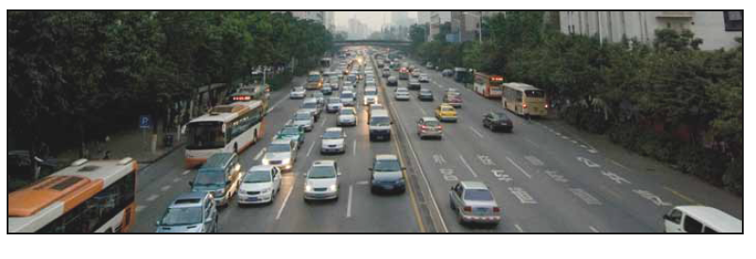

The potential of individual transport efficiency

Interdisciplinary bilateral winter and summer school on energy systems in Austria and the Czech republic

Balounová Veronika University of Prague / The University of Economics in Prague
Kerekes Thomas University of Graz / Karl-Franzens-Universität Graz


Content
1. Introduction 3
1.1 Trends and impacts of transport 3
1.2 Energy use of the transport sector 5
1.3 Emissions of the transport sector 6
2. The potential of the transport efficiency 10
2.1 Global Fuel Economy Initiative (GFEI) 10
2.1.1 Trends and potentials in fuel consumption and CO₂ emissions 11
2.1.2 The potential for improved fuel economy 12
2.1.3 The potential for reduction CO₂ emissions 12
2.1.4 The cost of fuel economy 14
2.2 Policy options 14
2.2.1 External costs of transport 16
2.3 Perspectives of effective transport 16
2.3.1 Technical and non-technical measures 16
2.3.2 New vehicle technologies 17
2.3.3 Biofuels and other alternative fuels 20
3. Relationship among built environment, auto ownership and travel behaviour 21
4. Conclusion 22
References 26

1. Introduction

1.1 Trends and impacts of transport
With freight and passenger transport are connected many negative impacts especially on the environment. Emissions significantly contribute to climate change and air pollution, noise affects nuisance and health risks, infrastructure influences landscape and ecosystems and occurrence of soil wastes near transport infrastructure. There are also impacts on society like deaths and injuries in accidents and time losses in congestions.
The most discussed problem of current society is climate change. There are many evidences from the last years about contribution of the emissions of greenhouse gas to the effect of global warming. As a major contributor are considered emissions of carbon-dioxide (CO₂) from the burning of fossil fuels which are intensely related to transport energy use. According to Intergovernmental Panel on Climate Change (IPCC) is projected that the globaly averaged surface air temperature will warm 1.1 to 6.4°C by 2100 relative to 2000 and globally averaged sea level will rise 18 to 59 cm by 2100. So it is the high time to start with immediate actions.
Trends in environmental and other impacts of transport are strongly influenced by the trends in transport volume. So we can say that transport play a critical role in reduction the CO₂ emissions levels according to global political climate change targets. The number of cars is expected to triple by 2050, in developing countries it forms 80 % growth. There are some opportunities to combine support for the industry because of the recession with environmental and energy policy goals.
Figure 1: Projected road and rail freight transport activity by region to 2050
Woodburn A., Allen J., Browne M., Leonardi J.: The Impacts of Globalisation on International Road and Rail Freight Transport activity - Past trends and future perspectives, Global Forum on Transportand Environment in Globalising World, 10-12 November 2008, Guadalajara, Mexico
Strong growth of transport volumes is affected by economic growth and in some part of the world, especially in EU, by the removal of internal borders and other market barriers. The improvements in efficiency have caused a reduction of real transport costs from which companies can benefit from differences in labour costs and skills in different regions. Transport over long distances has become more profitable than local transport. Altought some fuel efficiency improvements, the transport growth is a main driver of the growing energy demand which is expected to triple. The transport growth is formed from the number of vehicles and vehicle-kilometres. To go about emission factors it is good to use emission standards for pollutants and emission levels per kilometre for long distance transport. These options are described in separate chapter.
The transport sector counts for 7,1 % of GDP and vehicle manufacturing counts for 1.8 %. Also there is a lot of investment in transport infrastructure from the public and from the private sector. So that’s the point why it has such an economical importance. But not all actions are in an equitable market, because not everybody gets the benefits of the transport sector and some only the bad side of the medal. There are a lot of environmental impacts.

The essential economic and social benefits, which are so difficult to balance against the high
social and environmental costs, make transport a crucial sector for sustainable development.

Figure 2: Evaluation of changes in the sustainable transport theme (from 2000)
Eurostat: Measuring progress towardsa more sustainable Europe (Eurostat Statistical Books 2007)

1.2 Energy use of the transport sector
Over the last three decades the energy consumption of transport has almost doubled and is expected to once again doubled between 2000 and 2040. In the non-OECD countries the energy use over the last decades almost tripled and higher consumption is also predicted into the future. Road transport in both OECD and non-OECD countries contains the largest share of energy use, about three quarters, and is steadily increasing. On the base of this trend it is more significant global challenge to reduce energy consumption of transport and the related greenhouse gas emissions.
According to data of IPCC, rail transport is responsible for only 1.5 % of the global transport energy use compared with light duty vehicles (including passenger cars) with the highest share of 44 %. Other main energy users are aviation with 12 %, maritime shipping with 10 % and buses with 6 %. The view of transport energy consumption by mode and region is shown in the Figure 2.
Figure 3: Projection of transport energy consumption by mode and region

Essen H.: The Environmental Impacts of Increased International Roads and Rail Freight Transport - Past trends and future perspectives, Global Forum on Transportand Environment in Globalising World, 10-12 November 2008, Guadalajara, Mexico

Fossil fuels are the main energy sources for transport. Aside from electric rail, road transport, shipping and aviation are dependant on oil. The share of the transport sector in the world oil consumption is many times over the share in the world electric consumption. The share is steadily increasing and currently transport sector consume more then half of the world oil production.

While in the last years GDP has grown, the energy consumption of transport has also continued to increase.

When transport grows, it demands more energy. The energy consumption of transport in the EU-27 grew at an average rate of 1.3 % per year. This was only slightly less than the 1.7 % average for GDP over the same period.
Figure 4: Eurostat: Ratio of energy consumption of transport to GDP in (a) EU-15 and (b) EU-27 (index 2000=100)
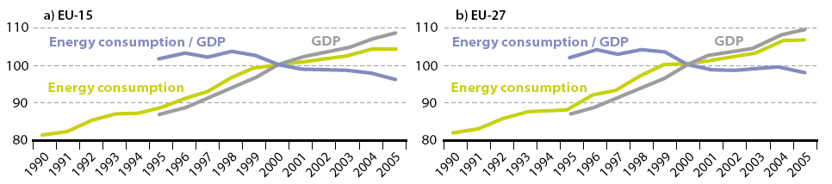
Eurostat: Measuring progress towardsa more sustainable Europe (Eurostat Statistical Books 2007)

Figure 5: Final energy consumption, EU-27, 2005: (% of total, based on tonnes of oil equivalent)
Figure 6: EU-27 energy consumption by transport

Eurostat: Measuring progress towardsa more sustainable Europe (Eurostat Statistical Books 2007)

The latest figures for passenger transport show that in 2004 cars were used for 84.8 % of inland passenger-km in the EU-15. That share is quite stable above the 1998 level of 84.5 % for several years, and shows us that this indicates a situation of stabilisation. But there are no signs of decoupling from GDP growth in recent years.

1.3 Emissions of the transport sector
All sectors together contribute to the steady growth of the greenhouse gas emission in the world. This trend tends to continue in spite of policy interventions like Kyoto protocol and are there big differences among sectors. Continual increasing of CO₂ emissions compared to decreases in other sectors is observed mainly by transport sector. The Figure 7 shows the increase of energy-related CO₂ emissions of transport sector from about one sixth in the early 1980s to now almost one fourth (23 %; in OECD circa 29 %). The projection for the global transport emissions per sector from 1970 to 2050 is shown in Appendix 1 (the transport CO₂ emissions are expected to double between 2000 and 2050).
Figure 7: Energy-related CO₂ emissions of various sectors (worldwide)
Essen H.: The Environmental Impacts of Increased International Roads and Rail Freight Transport - Past trends and future perspectives, Global Forum on Transportand Environment in Globalising World, 10-12 November 2008, Guadalajara, Mexico
In the situation of continued growth in transport CO₂ emissions, the significance of policy interventions must be taken into account.
Against increasing trend in energy use and climate change emissions, the emissions of pollutants have decreasing trend. But many European cities still have problems with achieving air quality standards which are steadily tightened. As a good way are considered stricter vehicle emission standards which can result in a global reduction of pollutant emissions.
The Greenhouse Gas emissions were about 25 % higher in 2005 than they were in 1990, but the growth rate is slowing, and emissions even fell in the EU-15 between 2004 and 2005. Moreover, emissions of some noxious pollutants, such as particulates and those responsible for summer smog, are continuing to decrease.

Transport is an important emitter of greenhouse gases. This sector is responsible for a growing share of total EU-27 emissions. It is also the only major source sector which is producing more greenhouse gas emissions than in 1990; every other sector having reduced its emissions. In that case transport is a critical sector to catch the Kyoto target.

Figure 8: GHG Emissions(*) by Sector – EU-27, million tonnes CO2 equivalent
Eurostat: EU energy and transport in figures (Statistical Pocketbook 2009)

Figure 9: GHG Emissions(*) from Transport – EU-27
Eurostat: EU energy and transport in figures (Statistical Pocketbook 2009)
Over the period 2000 to 2005, the average growth of greenhouse gas emissions from transport was still of about 1.2 % per year in the EU-27, compared to 0.9 % in the EU-15. However, emissions stabilised in the EU-27 between 2004 and 2005 and even decreased slightly in the EU-15.
Growth in greenhouse gas emissions from transport has slowed down below the growth rate of energy consumption. This is almost entirely due to slower growth in CO₂ emissions from road transport as a result of diesel supplanting petrol as the major road transport fuel and the lower average CO₂ emissions emitted per kilometre from new passenger cars.
In contrast to the continued increase in emissions of greenhouse gases, noxious emissions, such as particulates and those responsible for ozone formation have declined steadily since 1990 due to the progressive tightening of the technical standards required of new vehicles. The rate at which these new standards are absorbed into the vehicle fleet is dependent on the lifetime of different vehicle types and it can take many years before the full benefits of new legislation are realised. The introduction of catalytic converters in the early 1990s and subsequent stricter standards for emissions and transport fuels continue to have a beneficial effect in reducing pollutant emissions by road transport in the EU-27, which fell by 4.4 % per year on average between 2000 and 2004 for ozone precursors, and by 4.2 % per year for particulates.
It is also suitable to concentrate on the ways in which transport causes emissions. Emissions can be produce by vehicle usage (burning of fuels), fuel production, vehicle production, maintanance and disposal and also by infrastructure building, maintanance and adjustments. The major source of emissions is the first type. Approach concerned on emissions along the whole energy chain (production and burning of the fuel) is called „well-to-wheel“ and is shown in Figure 10. The emissions of vehicle usage for passenger cars are about 80 % of the total emissions.
Figure 10: Illustration of „well-to-wheel“ analysis of energy chains and „life-cycle analysis“ of products
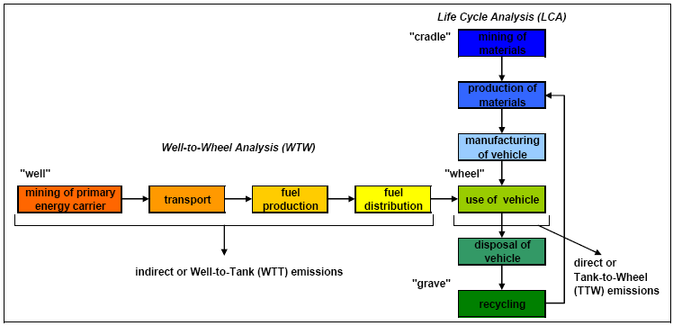
Essen H.: The Environmental Impacts of Increased International Roads and Rail Freight Transport - Past trends and future perspectives, Global Forum on Transportand Environment in Globalising World, 10-12 November 2008, Guadalajara, Mexico

2. The potential of the transport efficiency

2.1 Global Fuel Economy Initiative (GFEI)
Significant potential in the field of individual transport efficiency is seen in GFEI. The Initiative contains main steps, goals and priorities to achieve more efficient transport worldwide which can be also related to the theme of this seminar paper.
GFEI, launched in early 2009, is a initiative of group of four organisations – the FIA Foundation, International Energy Agency, International Transport Forum and United Nations Environment Programme. Their main goal is to improve vehicle efficiency worldwide, so they want „Making Cars 50 % More Fuel Efficient by 2050 Worldwide“. In this document are „fuel economy“ and „efficiency“ synonyms.
The aim of GFEI is to simplify large reductions of greenhouse gas emissions and oil use throught impovements in automobile fuel economy in the face of extensively growing car use worldwide (light-duty vehicles – cars, minivans, SUV´s). An improvement is targeted on average fuel economy (reduction in fuel consumption per kilometre) of 50 % worldwide by 2050. Another effect which is expected in addition to energy efficiency is a stabilisation of CO₂ emissions from the global car fleet. This step can contribute to meet the CO₂ targets defined by the International Panel on Climate Change (IPCC). Some predicted benefits are also significant reductions in oil expenditures and urban air pollutions around the world.
„The potential benefits are large and greatly exceed the expected costs of improved fuel economy. Cutting global average automotive fuel consumption (L/100 km) by 50 % (i.e. doubling MPG) would reduce emissions of CO₂ by over 1 gigatonne (Gt) a year by 2025 and over 2 gigatonne (Gt) by 2050, and result in savings in annual oil import bills alone worth over USD 300 billion in 2025 and 600 billion in 2050 (based on an oil price of USD 100/bbl). The Initiative proposes several steps and actions to work towards the 50:50 overall goal and each step will achieve some of this overall benefits.“
The Initiative have 4 priorities:
- Develop improved data and analysis of the current situation on fuel economy around the world
- Work with governments to develop sound policies to encourage fuel economy improvement for vehicles produced and/or sold in their countries
- Work with stakeholders (such as automakers) to better understand the potential for fuel economy improvements and solicit their support
- Support awareness initiatives to provide consumers and decision makers with information on options
The improvements are achievable by using more cost-effective vehicle technologies, change to conventional internal combustion engines and drive systems, weight reduction, better aerodynamics, full hybridisation of a wider range of vehicles and others. Big potential is seen also in the field of battery improvement – battery electric vehicles, plug-in hybrids and hydrogen fuel cell vehicles. „On-road“ efficiency is dependent on technology-based improvements but also on a low-cost efficiency improvements, which include programmes to promote efficient after-market products (replacement tyres), fuel-efficient driving style (ecodriving), improved traffic and speed management, better management of mobility in cities and others. Some countries also use regulatory standards for fuel consumptions or CO₂ emissions and reductions of highly polluting vehicles in circulation.
One main problem is connected with unstable oil prices, which can fall as well as rise. This can discourage car buyers from paying some premium price for efficiency and can also discourage automobile manufacturers from investing in highly fuel efficient vehicles because they can´t be sure of selling them. These risks can be reduced by government, which can facilitate the introduction of cost-effective fuel efficient technologies. Very important is cooperation between car manufacturers and government in order to adopt effective regulatory standards and incorporate international market considerations in the design of national tax incentives and labeling system.

2.1.1 Trends and potentials in fuel consumption and CO₂ emissions
According to IEA it is estimated that fuel consumption and emissions of CO₂ from the world´s cars will double between 2000 and 2050. Figure 11 shows possible „business-as-usual“ scenerios.
Figure 11: World CO₂ emissions from cars (Mt of CO₂ equivalent GHG, well-to-wheels; range of possible futures – CO₂ doubling or more by 2050 is possible)
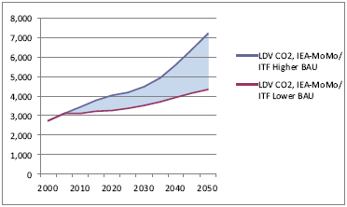
Source: IEA and ITF calculations using the IEA MoMo Model, Version 2008
ITF: Making Cars 50% More Fuel Efficient by 2050 Worldwide. Report, 50by50 Global Fuel Economy Initiative
Good ways how to don´t reach the higher-end trajectory of CO₂ emissions are fuel economy improvements, careful land-use planning, travel demand management, development of high quality transit systems which provide more efficient transport services compared to private cars and large shifts to low-carbon fuels. Than the central point of obtaining more sustainable picture of current trends is cutting vehicle fuel use per kilometre by half by 2050.
Currently cars are worldwide responsible for circa half of the transport sector´s fuel consumption and CO₂ emissions. Their dominant position is supposed to be remain but their share will fall by 2050 against aviation which will rise. There must be also taken into account a giant growth of the number of vehicles in developing and transition countries. The global growth in light duty vehicles is shown in Figure 12.
Figure 12: Global growth in light duty vehicles (tripling by 2050)
Source: IEA, Energy Technology Perspectives 2008
ITF: Making Cars 50% More Fuel Efficient by 2050 Worldwide. Report, 50by50 Global Fuel Economy Initiative
In the current situation of a rapid growth of car fleet plays a meaningful role electric vehicles. This vehicles are able to bring about significantly savings in gasoline and diesel and reduce CO₂ emissions. Great CO₂ reductions will be achieved by using electricity generated from low carbon or renewable resources by cars.

2.1.2 The potential for improved fuel economy
There exist big opportunity to improve new car efficiency 30 % by 2020 and 50 % by 2030 in a cost-effective way (low or negative cost per tonne of CO₂). Improving the fuel economy of new cars at this rate would evoke a 50 % improvement in the average fuel economy of all cars on the road worldwide by 2050. The potential is mainly seen in improving fuel economy rather than the performance of new model cars, in „plug-in“ hybrid vehicles and hydrogen fuel cell vehicles.
Nowdays average fuel economy levels vary country by country. In OECD was in 2005 this level around 8 litres per 100 km for new cars (SUVs and minivans; gasoline and diesel). If the improvement will be 50 % than the average fuel economy level would reach about 4 litres per 100 km (about 90 g/km CO₂).
The potential isn´t only by new cars, but also existing global vehicle fleet can be used more efficiently. It can be achieved by better engine tuning, better driving styles, more efficient after-market replacement parts (tyres and lubricating oils), reducing vehicle weight and reducing traffic congestion. GFEI Fuel efficiency target are shown in Appendix 2.

2.1.3 The potential for reduction CO₂ emissions
Reducing vehicle fuel use per km in half will lead to half rate of CO₂ emissions from cars. The level of CO₂ also depand on the types of fuels used, the rate of growth in cars ownership and distance driven per vehicle. More efficient cars can contribute to reducing other dangerous emissions like N₂O and black carbon which cause global warming. Figure 13 shows the potential impact of 50 % efficiency improvement by 2050 (stabilisation above the level of 2005).
Figure 13: CO₂ emissions from more fuel efficient cars (MT CO2 equivalent; improving new car fuel efficiency 50 % could stabilise world emissions through 2050)
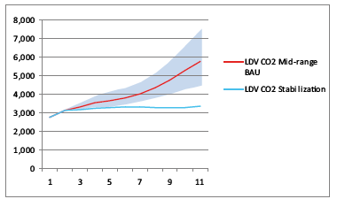
Source: ITF and IEA calculations using the IEA MoMo (January 2009)
ITF: Making Cars 50% More Fuel Efficient by 2050 Worldwide. Report, 50by50 Global Fuel Economy Initiative

In the matter of interest Figure 14 shows World tank to wheel CO₂ emissions and Table 1 shows Modal shares in world Vehicle CO₂-emission.

Figure 14: World tank to wheel CO₂ emissions (BAU, 2002 – 2050, Mt of CO₂-equivalent)
Dender K., Crist P.: Policy instruments to limit negative environmental impacts from increased international transport – An economic perspective, Global Forum on Transportand Environment in Globalising World, 10-12 November 2008, Guadalajara, Mexico

Table 1: Modal shares in world Vehicle CO₂-emission (BAU, 2000 – 2050, %)
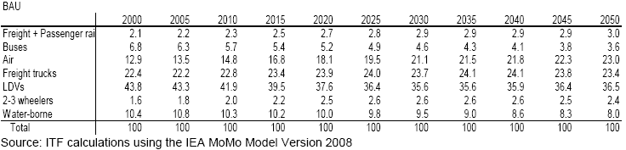
Dender K., Crist P.: Policy instruments to limit negative environmental impacts from increased international transport – An economic perspective, Global Forum on Transportand Environment in Globalising World, 10-12 November 2008, Guadalajara, Mexico

2.1.4 The cost of fuel economy
The cost of improving the efficiency of conventional engines and drivetrains are supposed to be relatively small because of the higher vehicle purchace price will be compensated by savings on fuel within a few years of car operation.
On fuel economy has serious effect the uncertainty. The uncertain factors which influence fuel economy choices can be lifetime of the car, the amount of driving, fuel prices and effective vs. labeled fuel economy. Low investments are mainly caused because of these uncertain factors.

2.2 Policy options
For the improvements in vehicle efficiency are significant fuel economy policies. Different countries have different approaches which depand on their individual situations, nature of their automobile markets, consumer demand profiles and others.
In road transport are relatively stringent pre-existing policies. The EU use high fuel taxes and may initiate fuel economy standards, the US has by contrast low fuel taxes and use fuel economy standards. In the EU is not road transport included in the ETS. The problem is that the wants for tighter fuel economy standards or higher fuel taxes in road transport in case of reducing greenhouse gass emissions are weak. Also the markets for fuel economy provide insufficient incentives to improve fuel economy to consumers because of various uncertainties connected with investments in fuel economy. With this market failures the good instrument for attaining higher car fleet efficiency are fuel economy standards and adoption of alternative technologies. Usage of less carbon to produce prevailing mobility patterns is expected to be cheaper way of reduction the risks of climate change compared to drastically changing the the structure of transport activity.

Standards
Worldwide countries have regulated the emission level of new vehicle (passenger cars and heavy duty vehicle). Every vehicle must meet some required emission standards at a prescribed test-cycle. Emission levels of new cars and test cycles differ across countries so they can not be fully comparable. But all have the same aim of promoting more efficient new cars. There are three main streams of standards (European, Japanese and American) and are used two major types of standards - fuel economy and CO₂ emissions standards. Fuel efficiency standards for passenger cars have been developed in many parts of the world and the tightest ones are in Europe.
In the field of transport have been developed and implemented many new technologies in order to fulfil required standards. For example various types of catalyst or diesel particulate filtres. In the coming decade is expected to further tightening of emission levels which can contribute to lowering pollutant emissions.
Vehicle taxes and incentives
Taxes can differ on the basis of vehicle fuel economy or CO₂ emissions where higher emission cars charge more then less emission cars. There exist governments tax vehicle purchases, annual taxes on vehicle ovnership or charges for an annual permit to drive on the roads.
Component standards, taxes and incentives
Some improvements in fuel economy can be achieved from progress in vehicle components like tyres, lubricating oils or air conditioners. These components affect fuel consumption and to promote a shift of them can be used regulatory standards or labeling and tax differenciation.
Fuel taxes
Direct impact on fuel economy have fuel taxes. Present fuel excise tax in Europe equate to a rate of 200 to 300 Euros per tone of CO₂ emitted by cars. High fuel taxes in some countries are created on the purpose of a carbon tax. There can appear question if fuel taxes or carbon taxes are sufficient to positive influence of vehicle purchase and vehicle use decision. It should be if the tax is set at the level which is identical with the carbon reduction target in road transport and if car buyers efficiently trade off investments in fuel economy against higher fuel expenditures and other car atributes (comfort, safety, power).
Testing and labeling
Cars are tested for fuel economy through standard procedures before they are sold. There are tested driving conditions at highway speeds and at urban driving speeds. Tests differ across countries, but results underestimate the real-life fuel consumption of vehicles. These test are mainly don´t practise in developing countries.
Car showrooms in many countries are obliged to display on windscreen labels the results of testing efficiency. These labels inform about vehicle fuel consumption and CO₂ emissions. These labeling systems are very different between countries so desirable is to provide consistent label system for international car markets.

2.2.1 External costs of transport
With transport are connected many external costs. Marginal external costs from automobiles displays the Appendix 3. These negative impacts are good to be accounted by energy and transport policies in order to defining policy priorities. Positive steps are fuel economy standards to reducing expected growth of emissions and larger deployment of alternative technologies. Finest step isn´t to reduce motor vehicle travel so much, but benefit is seen in technological changes in the field of energy savings, more fuel-efficient vehicles and alternative fuels.
The best way is to combine policy instruments to achieve fuel economy targets. Better alignment of fuel economy standards, labeling systems and tax systems worldwide would cause the adventage of providing vehicle manufacturers with common signals and also would bring down the cost of meeting the regulatory standards.

2.3 Perspectives of effective transport
Next to policy options exist some other opportunities for reduction of CO₂ emission and rest negative impacts from transport.

2.3.1 Technical and non-technical measures
Fuel costs play a significant part of the operating costs of vehicles. Efficiency improvements are in this reason very important drivers in vehicle and engine developments.
To reduce fuel consumption in passenger cars and other vehicles can be used also some non-technical measures like eco-driving, traffic measures and improved logistic.
As a fuel-efficient driving style is considered eco-driving. With this style can drivers of passenger cars save between 5 and 25 % fuel. Smaller potential is estimated for lorries (about 5 %). The CO₂ abatement cost connected with eco-driving depend on the costs of lessons, the expected effectiveness and the fuel price. The effectiveness of eco-driving is expected to decrease because of improvements in part-load efficiency of engine.
Many traffic measures can be implemented to regulate traffic flow and reduce driving dynamics like synchronisation of traffic lights and lowering speed limits on congested highways. This for sure contribute to reduction of fuel consumption and CO₂ emissions per vehicle kilometre. On the other hand it can also evoke increase in traffic because of improving the flow of traffic and reduction congestion. Traffic measures have only small potential for international transport where are used mainly motorways.
Reduction in fuel consumption by road freight kilometres in 10 to 20 % can be achieved by improved logistic. The steps are improved logistic organisation, better coordination between transport operators and improved route planning. On the other hand reduction of the overall transport costs (direct costs vehicle kilometres and the various costs related to time losses, storage, lower flexibility and others) can couse increase in transport demand which counteract the effort to reduce fuel consumption and CO₂ emissions.

2.3.2 New vehicle technologies
A number of new vehicle technologies are now coming on the markets that may have a significant market penetration over the next 20 years.
The following technologies are in detail:
- Electric vehicles
- Hybrid electric vehicles
- Fuel cell electric vehicles
Developments of conventional engines and emission control systems, like a direct injection for gasoline engines, are considered as an evolutionary development than a new technology. They will lead to improvements in emissions required by the future emission standards. But they are already included in some evaluations for the emission factor of the future in the coming vehicle categories.
Electric vehicles
Electric vehicles have got a long history, and competed on equal terms with the internal combustion engine vehicles until the 1920s. However, as the performance of internal combustion engines was developed, that of electric vehicles was unable to keep pace, and their popularity declined. Recently developed vehicles are able to perform much better but they still have a limited range between charges.
Some characteristics of electric vehicles are that they are quiet, emission free at point of use, they do not use energy while stationary and do not incur warm up losses. Electric motors provide very high efficiency at low speeds and a wide speed range. However, the performance and range of conventional electric vehicles is limited by the battery which accounts for a quarter of the vehicle's weight.
Hybrid electric vehicles
Hybrid electric vehicles combine an electric motor and a combustion engine. The series configuration consists of an engine which drives a generator producing electricity to drive the motor. This system operates a small engine at its most efficient condition, resulting in good fuel economy and low emissions. Systems are designed for the engine to work under high load conditions, where it is most efficient. Such a vehicle could operate as a battery electric vehicle in urban areas or at low speeds, while on the highway, the combustion engine would be the main source of power with the electric drive offering assistance when accelerating. The motor can also act as a generator, and be used to feed energy to the battery either from regenerative braking or when not all of the engine power is being used for propulsion.
Fuel cell electric vehicles
Fuel cells generate electricity directly from the chemical reaction of hydrogen and oxygen, and avoid the inefficiencies of conventional electricity production. Although the reaction responsible for generating the electricity is that between hydrogen and oxygen, a variety of fuels can be used to provide the hydrogen. Hydrogen itself can be used, but is not convenient to store in the vehicle and has no suitable distribution infrastructure.
Most development is focusing via organic liquid fuels, using an on-board reformer to extract the hydrogen. Methanol and gasoline have received the most attention, but other fuels may also be suitable. Estimating the penetration of new technologies over the next 20 years is difficult.
Historically, many new technologies have promised, but failed, to break the internal combustion engine monopoly. However, increasing pressure on the transport sector to mitigate its environmental impact will undoubtedly encourage change. A new vehicle must be technically and commercially viable and must meet customer demands if it is to gain a significant market share. The internal combustion engine is a well established and familiar technology that has developed a huge support industry with massive investment in production facilities and operational infrastructure.
A revolutionary movement towards a new technology has been considered unlikely.
Electric vehicles
It is likely that their widespread in Europe will require political assistance and new infrastructure, and both will take time to secure. It has been assumed therefore that Electric Vehicles (EV) sales in Europe will not be significant until the half of the next century and may account for 5 to 10% of the car market by 2020.
Hybrid electric vehicles:
Are becoming some impact in the near future. Concerns regarding the cost/benefit balance are being challenged. The Toyota Prius is now selling at far above projected rates since its introduction to the Japanese market in December 1997. Hybrid Electric Cars are offering good performance and very low fuel consumption and emission levels will be acceptable to the environmentally aware customer. It has been assumed therefore that this vehicle will account for 1-2 % of vehicle sales by 2010, rising to 5-10 % by 2020.
Fuel cell electric vehicle:
Are still far from production. The creation of a new supplier base andthe development of new techniques for mass production must be completed before Fuel Electric Vehicles will be available. It has been estimated that FCEVs will be available from the latter half of the next decade and that the market share in 2010 will be 0 %, rising to 10-20 % by 2020.
Table 2: Estimated percentage market share for new technology vehicles during the years 2010 and 2020
Mitrovich Sergio, (ENEA – Ente per le Nuove tecnologie, l’Energia e l’Ambiente), Energy and Transport, EU-funded Urban Transport Research Project ResultsEnvironment (2002), on-line: www.eu-portal.net

Figure 15: Total European fleet and estimates of new technology vehicles
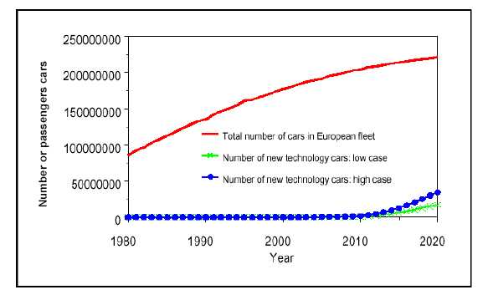
Environment, Energy and Transport - www.eu-portal.net (2002)
The graph above, which shows fleet growth between 1990 and 2020, the average car life is 15 years and that after 15 years the vehicle left the fleet. From these assumptions the number of cars leaving the fleet were estimated allowing the total number of new vehicles to be approximated each year. The percentage penetration of newtechnology vehicles into the European fleet is summarized in Figure 15.

2.3.3 Biofuels and other alternative fuels
The major energy source for the transport sector is oil. There are also some other possible energy sources which are more friendly to the environment compared to fossil fuels. This situation is illustrated in the Figure 16.
Figure 16: Various routes from primary energy sources, via secondary energy carriers to final use of energy in vehicles with different propulsion systems
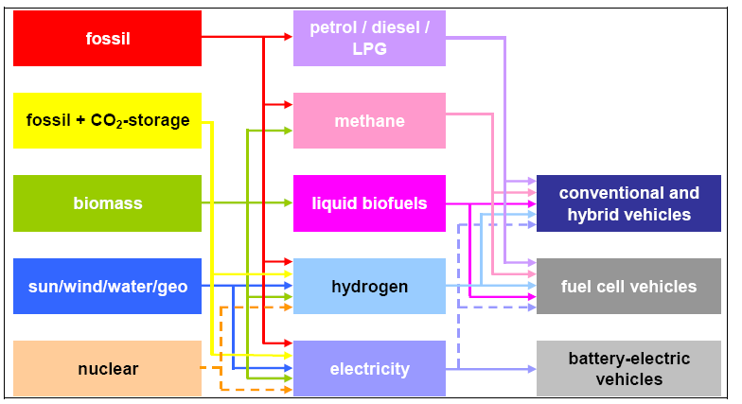
Essen H.: The Environmental Impacts of Increased International Roads and Rail Freight Transport - Past trends and future perspectives, Global Forum on Transportand Environment in Globalising World, 10-12 November 2008, Guadalajara, Mexico
As clean fossil alternatives for petrol and diesel are presented LPG (Liquefied Petroleum Gas) and CNG (Compressed Natural Gas). CO₂ emissions of LPG vehicles are in between those of petrol and diesel vehicles and the well-to-wheel greenhouse gas emission of CNG vehicles are circa 20 % lower than those of petrol vehicles and almost the same as those of diesel vehicle. The CO₂ benefits of CNG are connected with the quality of the natural gas and transport distances.
In recent years production and use of biofuels is strongly increasing worldwide. Biofuel industry is devided into two main sectors – biodiesel and bioethanol. Globally production of bioethanol is ten times higher than the production of biodiesel, in the EU the situation is reverse. The share is influenced by government policies of each states, the potential of rapeseed production (main raw material that can be converted to biodisel) and high share of diesel in EU fuel sales. The adventage of biofuels is that the amount of CO₂ emitted during combustion is same as the CO₂ produced by the biomass during cultivation. Outcome is that biofuels still contribute to global warming because of cultivation of biomass, transport and production of the biofuels. But in comparison with fossil diesel and petrol, biofuels can achieve greenhouse gas reduction about 30 to 60 % and new biofuel processes are under developement. These new biofuels are called second-generation biofuels and is expected to achieve greenhouse gas reduction of 80 – 90 %.
There are also some negative effects of biodisel. The first is the higher price than that of fossil fuels and second effect is connected with biodiversity. The rise of the demand for biomass caused pressure on farmland, forest biodiversity and soil and water resources. In this case it is very important to implement environmental impacts as integral part of planning processes at the local, national and EU level.
Our future energy problems will be solved according to many authors by „hydrogen economy“. But there are many discussions whether distribution of energy in the form of hydrogen is the best solution. Another significant source of energy supply into the future is considered electricity. The usage of electricity in transport can bring some well-to-wheel efficiency benefits which are connected with the current EU-mix for electricity generation.

3. Relationship among built environment, auto ownership and travel behaviour
In the field of individual transport efficiency and its potential can somebody ask if neighborhood design independently influences travel behaviour or whether preferences for travel options and travel attitudes affect residental choice. Residental individual self-selection can play a notable role (for example if somebody prefere walking than he can live in walkable neighboorhoods and vice versa).
Outcome of many studies was that people in suburban neighborhoods drive more and walk less than residents in traditional environments. In this case is suburban sprawl very criticised becouse of it´s contribution to auto dependance. Results of some studies point out on importance of land-use policies. If they are designed to locate residents closer to destinations and provide them some alternative transportation options people will probably less drive and more walk.
The data for one study which examine relationship among changes in built environment, changes in auto ownership and changes in travel behaviour was obtained from 547 movers living in four traditional neighborhoods and four suburban neighborhoods in Northern California. Respondents were at first asked on their changes in preferences in current and previous neighborhood characteristics which were measured on point scale (accessibility, physical activity options, safety, socializing, attractiveness and outdoor spaciousness). Another parts of questionare were travel attitudes (pro-bike/walk, travel minimizing, safety of car, car dependent) and socio-demographics. More information are shown in Appendix 4.
This study have many limitations but also provide significant results which are good to také into account. The first output is that residental self-selection has sustainable impact on travel behaviour (neighborhood preferences and travel attitudes - affect choice of residental neighborhood which than affect travel behaviour and affect auto ownership, driving behaviour and walking behaviour). The second output point out that changes in the built environment have notable association with changes in travel behaiour (current attitudes , changes in socio-demographics; according to the study the most important factorin reducing driving is increase in accessibility). Next result is that there is connection from the built environment to driving and walking behaviour (attractiveness, physical activity options like parks, bike routes, sidewalks and public transport, safety and socializing). Finally was foud that travel behaviour have greater effects on built environment compared to socio-demographics.

4. Conclusion
Transport sector causes many environmental impacts like emissions of air pollutants, CO₂ and noise. The share of this emission is steadily increasing and the major driver is road transport.
The air pollutions from transport are decreasing because of tightening vehicle emission standards in comparison with CO₂ emissions which are continually incresing all over the world.
Some energy experts say, that there is nothing which can magically halt or reverse global warming. There appears importance of improvements in existing technologies and new ones which will more cleanly and economically power the computers, refrigerators, trucks, cars and others. As possible steps how to divert climate changes come up energy efficiency, nuclear power, „clean“ coal, hybrid vehicles, wind power, biofuels and carbon dioxide sequestration.
The transport trends and their environmental impacts are strongly influenced by the growth of transport volume. The good way how to reduce negative impacts of transport is throught limiting the expected growth of transport volume. Current technical options seem not be sufficient in order to reduce increasing amount of CO₂ emissions, so an effective mix of measures for limiting contribution of transport to global warming are needed. The good steps are improving fuel efficiency of vehicles, new vehicle technologies, alternative fuels, logistical improvements and many others.
Main role also play an effective policy for reduction the negative impacts of transport which can use regulation, infrastructure measures or pricing measures.
As summary, now we can see that only a mixture of instruments and technological changes can lead to the development in mobility and reducing emissions which count for the global warming on our planet earth.

Appendix 1: Historical and projected CO₂ emissions from transport by mode (worldwide)
Essen H.: The Environmental Impacts of Increased International Roads and Rail Freight Transport - Past trends and future perspectives, Global Forum on Transportand Environment in Globalising World, 10-12 November 2008, Guadalajara, Mexico

Appendix 2: GFEI Fuel efficiency targets (relative to a 2005 baseline)
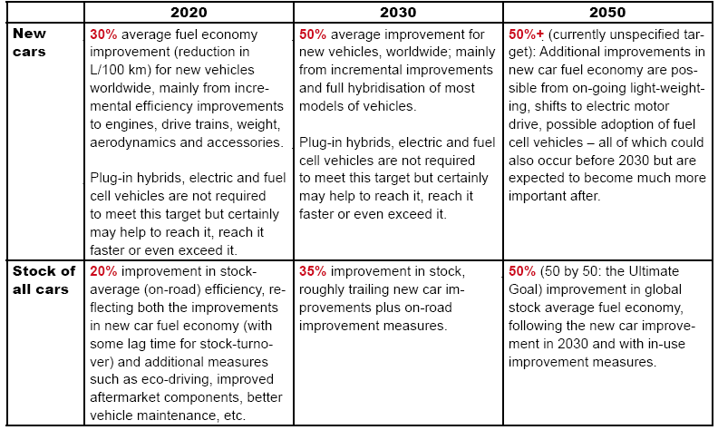
ITF: Making Cars 50% More Fuel Efficient by 2050 Worldwide. Report, 50by50 Global Fuel Economy Initiative

Appendix 3 : Marginal external costs from automobiles (US cents/mile, 2005 prices)
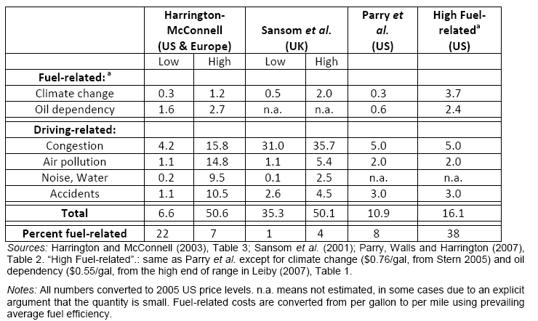

Dender K., Crist P.: Policy instruments to limit negative environmental impacts from increased international transport – An economic perspective, Global Forum on Transportand Environment in Globalising World, 10-12 November 2008, Guadalajara, Mexico
Appendix 4: Key variables loading on the neighborhood characteristics and travel attitude factors that are significant in the final model
Note: The numbers in parentheses are the pattern matrix loadings for the obliquely rotated factors (Handy et.al. 2004)
Cao X., Mokhtarian P. and Handy S.: Do changes in neighborhood characteristics lead to changes in travel behavior? A structural equations modeling approach, Springer Science + Business Media B. V. 2007

References
Cao X., Mokhtarian P. and Handy S.: Do changes in neighborhood characteristics lead to changes in travel behavior? A structural equations modeling approach, Springer Science + Business Media B. V. 2007
Dender K., Crist P.: Policy instruments to limit negative environmental impacts from increased international transport – An economic perspective, Global Forum on Transportand Environment in Globalising World, 10-12 November 2008, Guadalajara, Mexico; on-line: http://www.oecd.org/dataoecd/12/53/41612575.pdf
Eurostat, EU energy and transport in figures, Statistical Pocketbook 2009, (2009)
Eurostat, Measuring progress towardsa more sustainable Europe, Eurostat Statistical Books 2007, (2007)
Essen H.: The Environmental Impacts of Increased International Roads and Rail Freight Transport - Past trends and future perspectives, Global Forum on Transportand Environment in Globalising World, 10-12 November 2008, Guadalajara, Mexico; on-line: http://www.oecd.org/dataoecd/10/62/41380980.pdf
Gehring M.: Policy Instruments to Limit Negative Environmental Impacts from Increased International Transport – Constraints and Opportunities in International Law, Global Forum on Transportand Environment in Globalising World, 10-12 November 2008, Guadalajara, Mexico; on-line: http://www.oecd.org/dataoecd/16/9/41579487.pdf
Hook W.: Mitigatin the Risk of Climate Change by Reducing Travel by Light Duty Vehicles, Global Forum on Transportand Environment in Globalising World, 10-12 November 2008, Guadalajara, Mexico; on-line: http://www.oecd.org/dataoecd/11/41/41605405.pdf
ITF: Making Cars 50% More Fuel Efficient by 2050 Worldwide. Report, 50by50 Global Fuel Economy Initiative, on-line: http://www.internationaltransportforum.org/docs/pdf/50BY50_report.pdf
Kriz M.: No Silver Bullet, National Journal, Washington: Aug 5, 2006; on-line: http://proquest.umi.com/pqdweb?index=5&did=1095757811&SrchMode=1&sid=3&Fmt=3&VInst=PROD&VType=PQD&RQT=309&VName=PQD&TS=1235908368&clientId=45149
Mitrovich Sergio, (ENEA – Ente per le Nuove tecnologie, l’Energia e l’Ambiente), Energy and Transport, EU-funded Urban Transport Research Project ResultsEnvironment (2002), on-line: www.eu-portal.net
Woodburn A., Allen J., Browne M., Leonardi J.: The Impacts of Globalisation on International Road and Rail Freight Transport activity - Past trends and future perspectives, Global Forum on Transportand Environment in Globalising World, 10-12 November 2008, Guadalajara, Mexico; on-line: http://www.oecd.org/dataoecd/52/29/41373591.pdf

Essen H.: The Environmental Impacts of Increased International Roads and Rail Freight Transport - Past trends and future perspectives, Global Forum on Transportand Environment in Globalising World, 10-12 November 2008, Guadalajara, Mexico
Essen H.: The Environmental Impacts of Increased International Roads and Rail Freight Transport - Past trends and future perspectives, Global Forum on Transportand Environment in Globalising World, 10-12 November 2008, Guadalajara, Mexico
ITF: Making Cars 50% More Fuel Efficient by 2050 Worldwide. Report, 50by50 Global Fuel Economy Initiative
Essen H.: The Environmental Impacts of Increased International Roads and Rail Freight Transport - Past trends and future perspectives, Global Forum on Transportand Environment in Globalising World, 10-12 November 2008, Guadalajara, Mexico
Eurostat: Measuring progress towardsa more sustainable Europe (Eurostat Statistical Books 2007)
Eurostat: Measuring progress towardsa more sustainable Europe (Eurostat Statistical Books 2007)
Essen H.: The Environmental Impacts of Increased International Roads and Rail Freight Transport - Past trends and future perspectives, Global Forum on Transportand Environment in Globalising World, 10-12 November 2008, Guadalajara, Mexico
Eurostat: Measuring progress towardsa more sustainable Europe (Eurostat Statistical Books 2007)
Eurostat: Measuring progress towardsa more sustainable Europe (Eurostat Statistical Books 2007)
Essen H.: The Environmental Impacts of Increased International Roads and Rail Freight Transport - Past trends and future perspectives, Global Forum on Transportand Environment in Globalising World, 10-12 November 2008, Guadalajara, Mexico
Essen H.: The Environmental Impacts of Increased International Roads and Rail Freight Transport - Past trends and future perspectives, Global Forum on Transportand Environment in Globalising World, 10-12 November 2008, Guadalajara, Mexico
Eurostat: EU energy and transport in figures (Statistical Pocketbook 2009)
Eurostat: EU energy and transport in figures (Statistical Pocketbook 2009)
Essen H.: The Environmental Impacts of Increased International Roads and Rail Freight Transport - Past trends and future perspectives, Global Forum on Transportand Environment in Globalising World, 10-12 November 2008, Guadalajara, Mexico
ITF: Making Cars 50% More Fuel Efficient by 2050 Worldwide. Report, 50by50 Global Fuel Economy Initiative, on-line: http://www.internationaltransportforum.org/docs/pdf/50BY50_report.pdf
ITF: Making Cars 50% More Fuel Efficient by 2050 Worldwide. Report, 50by50 Global Fuel Economy Initiative, on-line: http://www.internationaltransportforum.org/docs/pdf/50BY50_report.pdf
ITF: Making Cars 50% More Fuel Efficient by 2050 Worldwide. Report, 50by50 Global Fuel Economy Initiative
ITF: Making Cars 50% More Fuel Efficient by 2050 Worldwide. Report, 50by50 Global Fuel Economy Initiative
ITF: Making Cars 50% More Fuel Efficient by 2050 Worldwide. Report, 50by50 Global Fuel Economy Initiative
Dender K., Crist P.: Policy instruments to limit negative environmental impacts from increased international transport – An economic perspective, Global Forum on Transportand Environment in Globalising World, 10-12 November 2008, Guadalajara, Mexico
Dender K., Crist P.: Policy instruments to limit negative environmental impacts from increased international transport – An economic perspective, Global Forum on Transportand Environment in Globalising World, 10-12 November 2008, Guadalajara, Mexico
Essen H.: The Environmental Impacts of Increased International Roads and Rail Freight Transport - Past trends and future perspectives, Global Forum on Transportand Environment in Globalising World, 10-12 November 2008, Guadalajara, Mexico
ITF: Making Cars 50% More Fuel Efficient by 2050 Worldwide. Report, 50by50 Global Fuel Economy Initiative
ITF: Making Cars 50% More Fuel Efficient by 2050 Worldwide. Report, 50by50 Global Fuel Economy Initiative
ITF: Making Cars 50% More Fuel Efficient by 2050 Worldwide. Report, 50by50 Global Fuel Economy Initiative
Dender K., Crist P.: Policy instruments to limit negative environmental impacts from increased international transport – An economic perspective, Global Forum on Transportand Environment in Globalising World, 10-12 November 2008, Guadalajara, Mexico
ITF: Making Cars 50% More Fuel Efficient by 2050 Worldwide. Report, 50by50 Global Fuel Economy Initiative
Dender K., Crist P.: Policy instruments to limit negative environmental impacts from increased international transport – An economic perspective, Global Forum on Transportand Environment in Globalising World, 10-12 November 2008, Guadalajara, Mexico
Essen H.: The Environmental Impacts of Increased International Roads and Rail Freight Transport - Past trends and future perspectives, Global Forum on Transportand Environment in Globalising World, 10-12 November 2008, Guadalajara, Mexico
Environment, Energy and Transport - www.eu-portal.net (2002)
Environment, Energy and Transport - www.eu-portal.net (2002)
Environment, Energy and Transport - www.eu-portal.net (2002)
Mitrovich Sergio, (ENEA – Ente per le Nuove tecnologie, l’Energia e l’Ambiente), Energy and Transport, EU-funded Urban Transport Research Project ResultsEnvironment (2002), on-line: www.eu-portal.net
Cao X., Mokhtarian P. and Handy S.: Do changes in neighborhood characteristics lead to changes in travel behavior? A structural equations modeling approach, Springer Science + Business Media B. V. 2007
Kriz M.: No Silver Bullet, National Journal, Washington: Aug 5, 2006

